***LEVEL UP – GAMIFIED PRODUCTIVITY APP***

# **The domain of the Project:**

# G5 - UIUX

# **Team Mentors (and their designation):**

# Sir Sen Ghiri Sudhan

# UI/UX Designer - MetricStream

# **Team Members:**

Ms. Trupti Zaware

# **Period of the project**

# **July 2025 to December 2025**

Declaration

The project titled “Level Up – Gamified Productivity App” has been mentored by Sir Sen Ghiri Sudhan, organised by SURE Trust, from July 2025 to December 2025, for the benefit of the educated unemployed rural youth for gaining hands-on experience in working on industry relevant projects that would take them closer to the prospective employer. I declare that to the best of my knowledge the members of the team mentioned below, have worked on it successfully and enhanced their practical knowledge in the domain.

Team Members:

Ms. Trupti Zaware

Signature

Mentor’s Name – Sir Sen Ghiri Sudhan

Designation- UI/UX Designer - MetricStream

Prof. Radhakumari

Executive Director & Founder

SURE Trust

Table of contents

1. Executive summary
2. Introduction
3. Project Objectives
4. Methodology & Results(Screenshots)
5. Learning & Reflection
6. Future Scope & Conclusion

***Executive Summary***

* LevelUp is a gamified productivity mobile application designed to help working professionals manage tasks while staying motivated.
* The project focuses on combining traditional task management with game-like elements such as XP, levels, and progress tracking.
* The complete UI/UX process was followed, starting from user research to final high-fidelity UI screens.
* The application is designed for both Android and iOS platforms using a user-centric approach.

***Introduction***

* Many working professionals struggle with consistency, motivation, and task prioritization while using conventional to-do apps.
* Most productivity tools lack engagement and fail to motivate users over time.
* The LevelUp project was initiated to solve this problem by introducing gamification into daily task management.
* The scope of this project includes user research, user flow creation, wireframing, UI design, and experience optimization.
* Development was not part of the project scope.
* The innovation lies in blending productivity with motivational design elements.

***Project Objectives***

* To understand productivity challenges faced by working professionals
* To design a motivating task management experience
* To create clear and simple user flows
* To design a complete mobile app UI for iOS and Android
* To encourage habit formation through gamification

***Methodology and Results***

**Methodology Used:**

* User research and problem identification
* Persona creation and user journey mapping
* Information architecture and task flows
* Wireframing and high-fidelity UI design

**Tools Used:**

* Figma (UI design)
* FigJam (flows and brainstorming)
* Notion (documentation)

**Project Architecture:**  
Onboarding → Home Dashboard → Task Creation → AI Suggestions → XP & Levels → Progress Tracking → Profile & Settings

**Final Output:**  
The result is a fully designed mobile application with consistent UI, clear navigation, and engaging gamification elements.

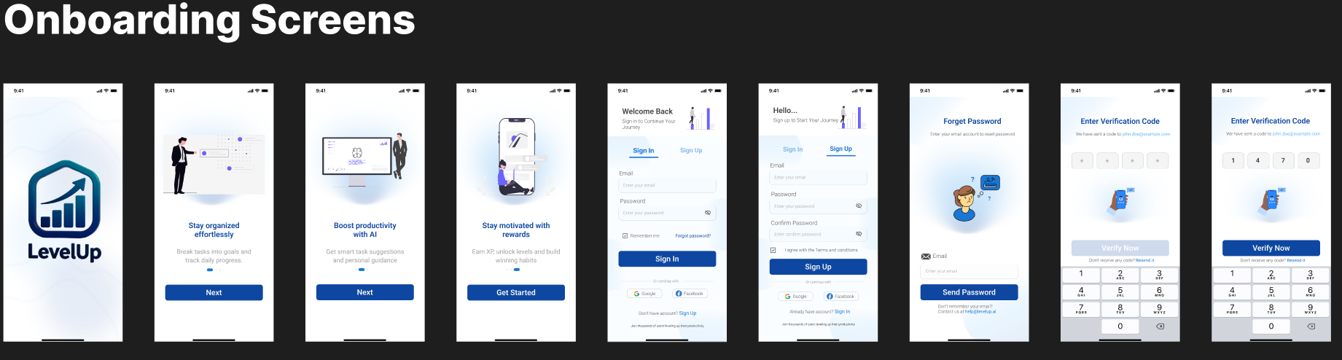

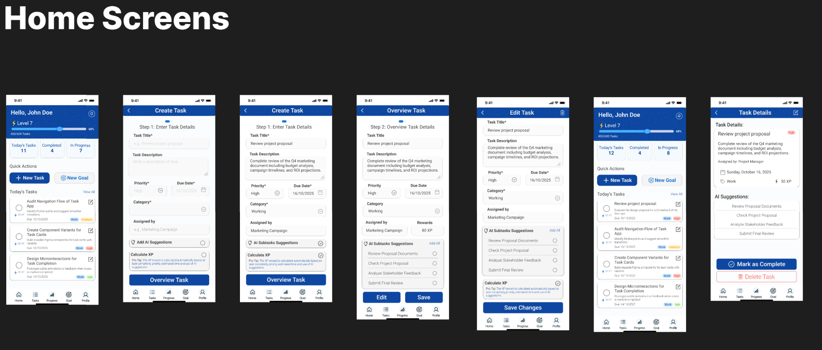

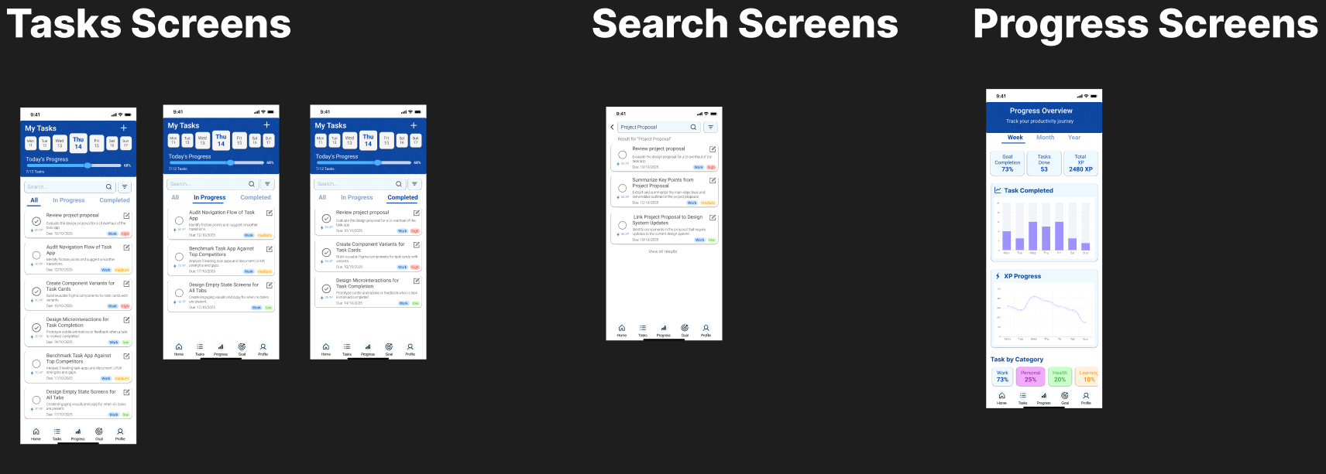

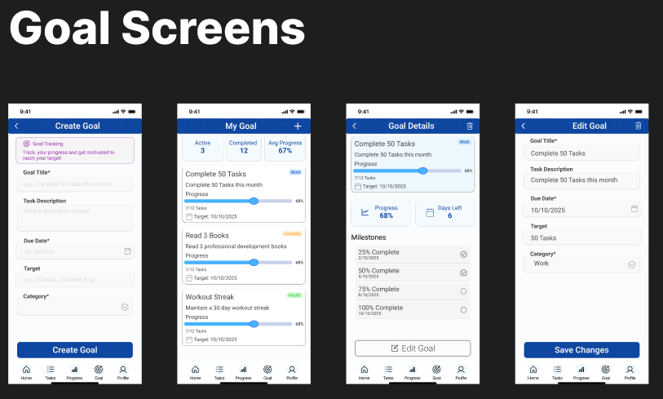

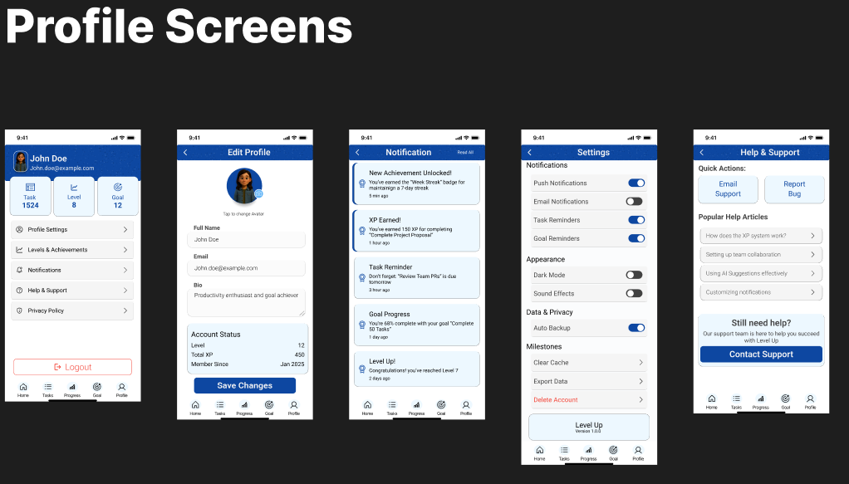

***Learning and Reflection***

* Through this project, I learned how to conduct user-centric design, structure complex flows, and apply gamification thoughtfully.
* It strengthened my understanding of end-to-end UI/UX design.

***Conclusion and Future Scope***

* The project successfully meets its objectives by providing a motivating productivity experience.
* In the future, usability testing, AI optimization, and development integration can enhance the product further.